Description of Cat Mario Game

In order to build our game today, we're going to draw our own backdrop, and use a lot of 'if-then' blocks in S cratch coding to both check and see if two sprites are touching, and also allow ourselves to control a sprite with the arrow keys on our keyboard. Here's a link to the F inished Project.

Draw the back drop

First of all, go to “add a back drop” in the right bottom, place the arrow on it, it will popup a new menu, select paint. Now in the paint screen, select rectangle, choose the specific color and draw a rectangle all over the paint area. Now lighten the selected color and add long rectangles on the screen in specific order as the mirror shade. It will look like this:
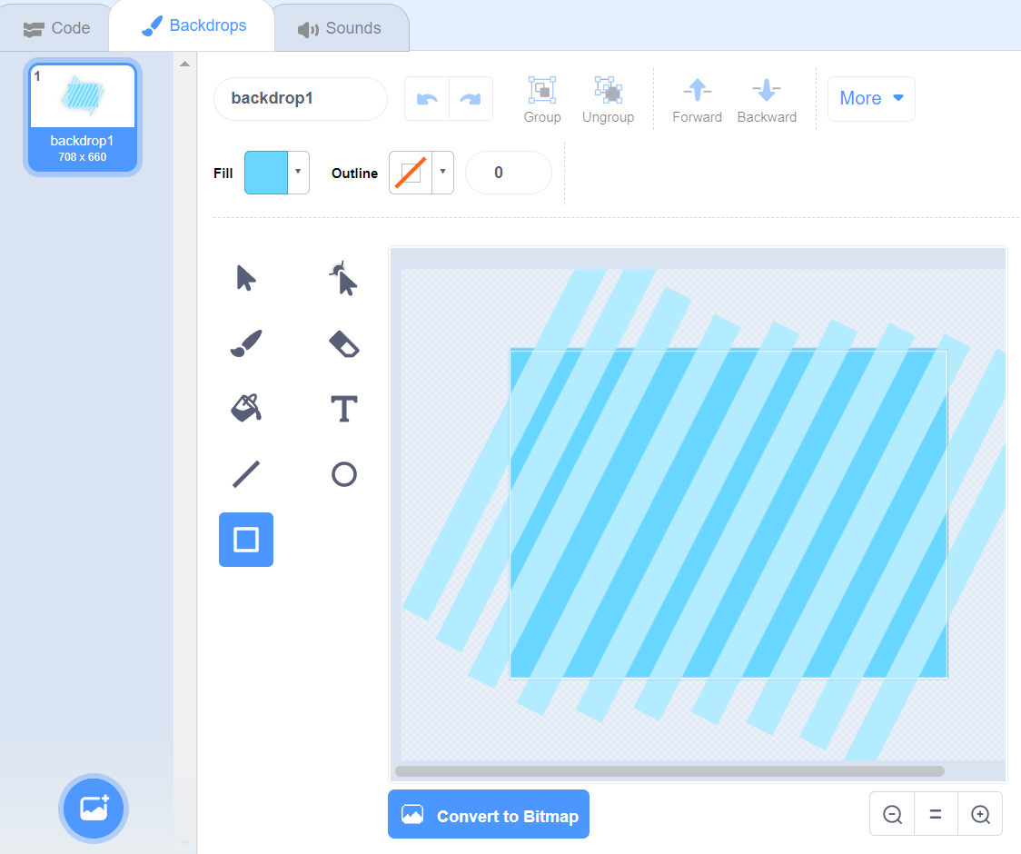

Pick your sprites

Now its time to add i, one sprite is already added which is a cat. For more, go to “add sprites” in the right bottom. Space arrow on it, a popup will display. Select paint, in paint screen, I have used different shapes, first of all see the following pics

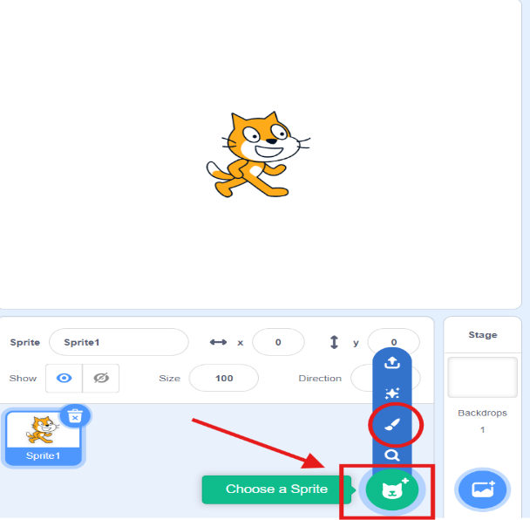

Drawing our levels as sprites

I have drawn so many rectangles for each sprite. The question is how did I curve a rectangle and shown as a slide? The second option in the right of arrow icon which is also highlighted is the answer.
: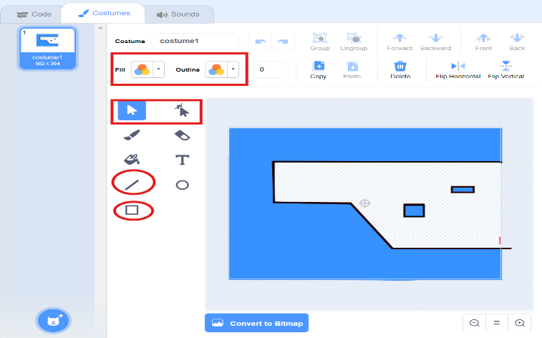

After that I manually outline every this, the main thing is the color of the outlining. Which is not purely black, I used the following color scheme.

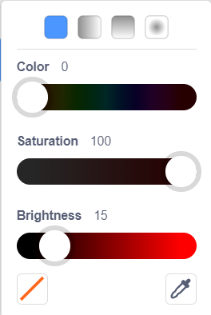

Note: This color scheme is used all over the game and each slide for outlining. Actually this is color is used to control the gravity of the cat.

Other sprites and levels:

On the same scheme, i have drawn different sprites and named them as “Ground 1, Ground 2, Ground 3 and so on” Some of them are presented in the following picture:
2.
1.
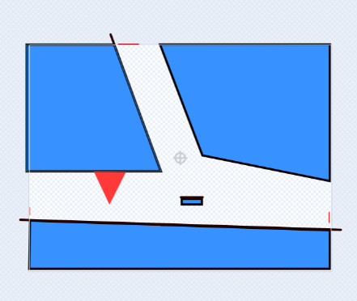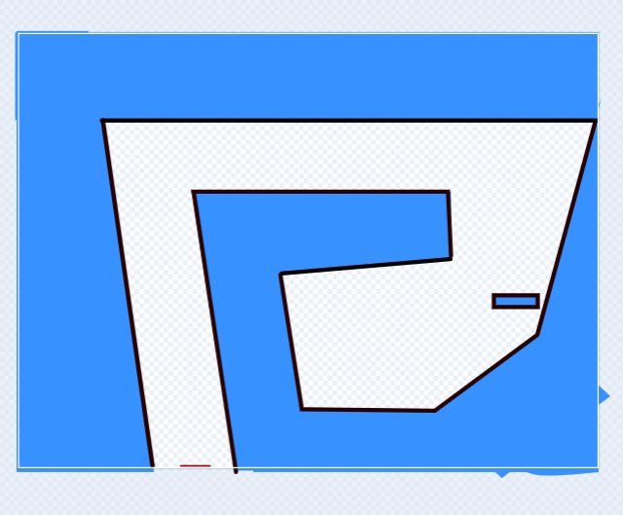
3.
4.
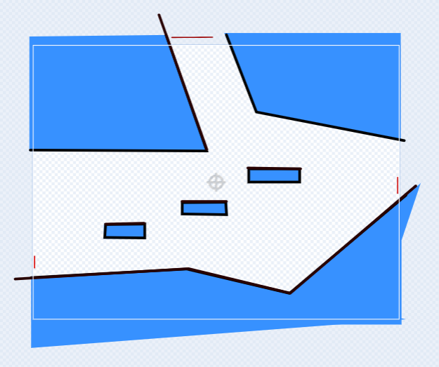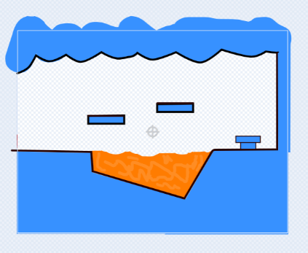

Note: These all are drawn using same concept described above. The above-mentioned scheme is used all over the game as the floor for the cat. The cat will run over that specific color only and consider it as a floor.

Movement of the cat

It is simple to move the cat sprite up, down, left, right etc by changing the value of x and y. But I have also changed the direction of the cat with its movement. Such as when we press forward button, which is “d” in my case, the cat’s face is in forward direction and when we press back ward button, cat faces in the back direction. For that, I copied the first costume of cat, select all and flip it horizontally. Moreover, when we press “s” button which is down button, the cat head’s down. The code and costumes re shown in the following picture:
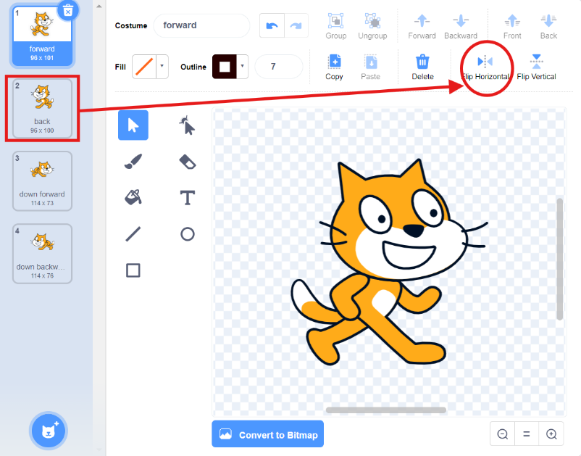
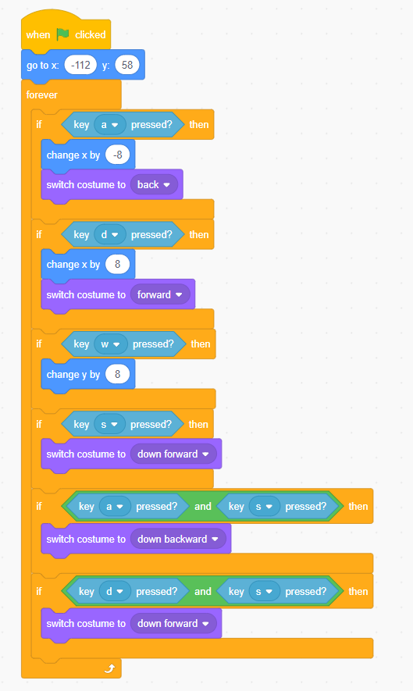
In the above code, I change the costume to “back” when backward key (a) is pressed and vise versa. And the value of x will change by -8 which is actually the speed. Minus (-) sign indicates that the cat will change the value of x in negative which is actually backward. In the movement of cat, some problems occur when we press both “s” and “a” key Because “s” key tells to switch the costume to “down” where as “a” is telling to switch costume to “back”.
To solve that, I used and operator as shown so that in case when both keys pressed a new costume named “down backward” will appear. Same is the same with the other case.

Gravity controller

Without the gravity affect, there is no point in the game. So, to add gravity in the game, we use a technique which isas follow: We make a variable gravity. The value of gravity will remain zero as long as the cat will remain in touch with that specific color black color (floor, which is mentioned above is the “Drawing our level in sprite” section. And it will change by -1 when the cat will in the air (jump). After that, we will change the value of Y with respect to the variable “Gravity”.
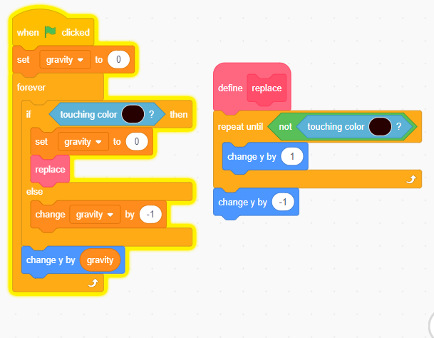

There is still a problem that the gravity effect is acting with the reference to Center of object. So, to solve that problem, when ever the cat touches that specific color, the Y will change by 1, so that the cat will move a slightly upward. For this, we had to make a separate block named “replace”. And when the cat is in the air (not touching that color), The Y will again change by -1 so that it will seem a normal movement.
Now without this Replacement of cat, the cat will be shown as:

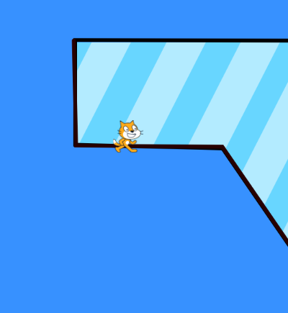

It looks like pretty uncool, so this replacement was essential.

Moving from One ground to another

The most time taking and difficult task in this game is to move from one sprite to another. It took too much of my time. Afterall, I used different color schemes to show different broad casts and on each broad cast, a specific sprite hides it self and the other specific sprite shows itself. I also define the placement of our cat when the specific color is touched by it and a broadcast appears and the next sprite will show.
Here is some of the color schemes defined because those are so many to display all.

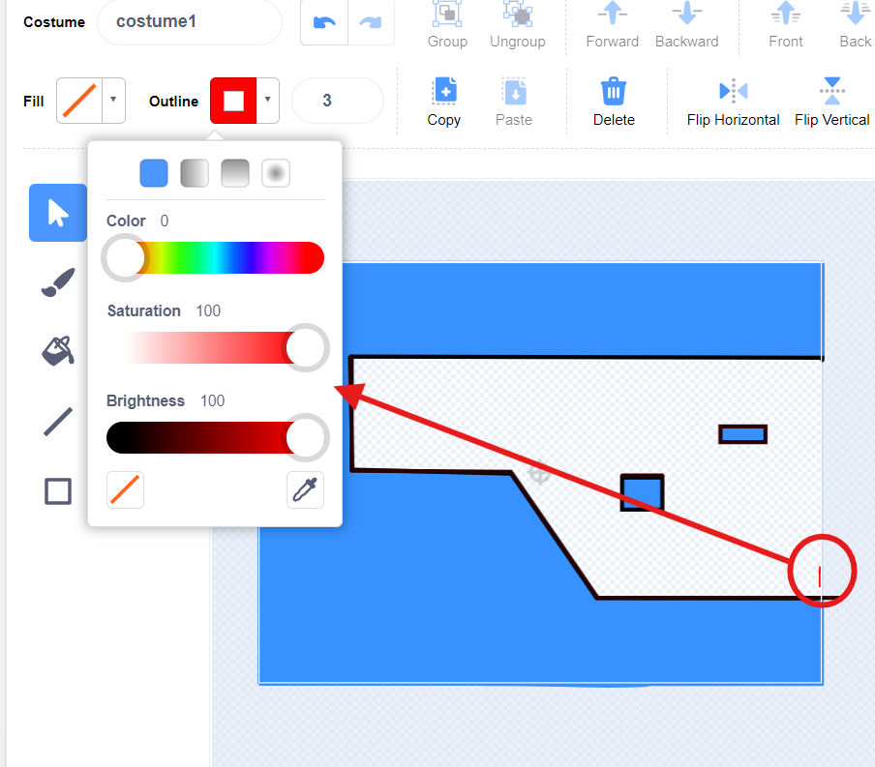

As we can see in this picture, I have added a special color ant the end of sprite one which is circled. It has the following properties:
- Color 0
- Saturation 100
- Brightness 100
When the cat touches this color, the following piece of code will run:
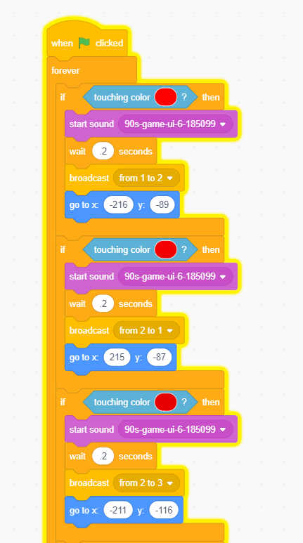

For now, we are only considering the highlighted part. It also has the same color specifications:
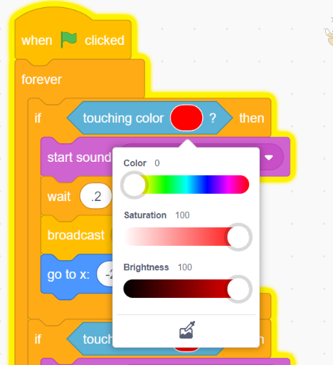
Now when ever the cat touches the following color, a sound will play and will wait for 0.2 second (both are not compulsory, it is choice), The actual part is broadcast, I named first broadcast “from 1 to 2” as I’m moving from my ground 1 to ground 2. And define the position of my cat in the next sprite when it will show.
Now in the ground 1, I define the following:
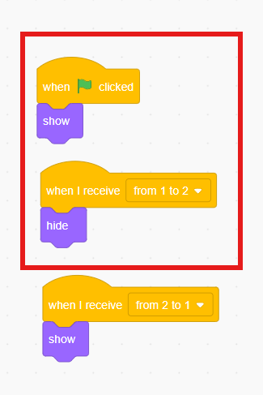
For now, I am just considering the highlighted part. When the game starts, the Ground 1 will show and when the broadcast message “from 1 to 2” will appear, this sprite will hide.
On the other hand, in sprite 2 or ground 2, the following code is defined:
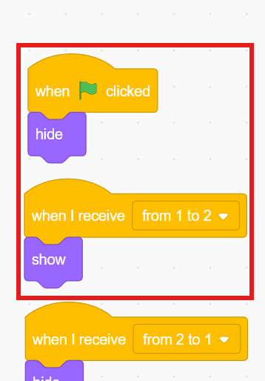
Again, only considering the highlighted one, in my second ground, when the game starts, this sprite, like all other sprites except the first one, will remain hide. Now when the specific broad cast message will receive, in this case, “from 1 to 2”, it will be shown. And due to that placement of cat through “change x and y by” function, the cat will be at the start of that sprite.

Same is the case with other sprites, I used different colors with different specifications for sensing. Some samples are given below:
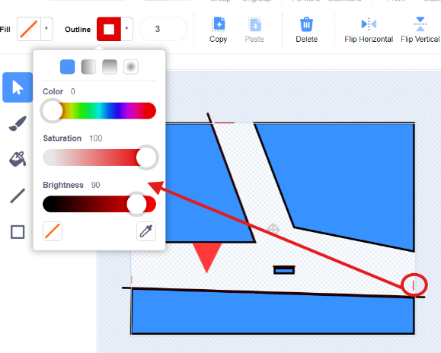
I used this to go from ground 2 to ground 3.
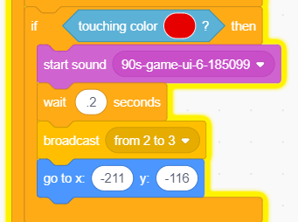
This is the code in which I used the same color scheme.
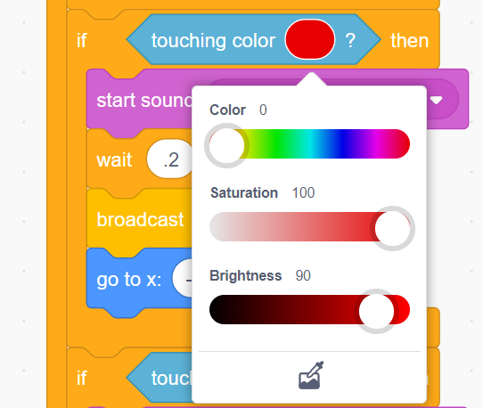
When the ground 2 will receive broad cast message “from 2 to 3” then it will hide itself.
And when the ground 3 will receive the same message, it will show and the cat will move to the defined position (obviously at the start of the ground).

Scoring System

To add score, I made a variable named “score” and when the green flag is pressed, it is automatically sets to zero. To do an increase in the score, I made a sprite named as “star”. When ever the cat touches the star, it will make an increase of 1 in the score and star will disappear. The code of this is as follows.
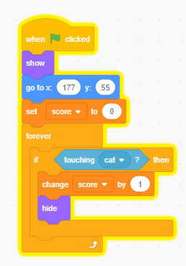

The position defined in the above code is valid only for the first ground. This code is written in the star sprite.
For other grounds, the code is as follows:

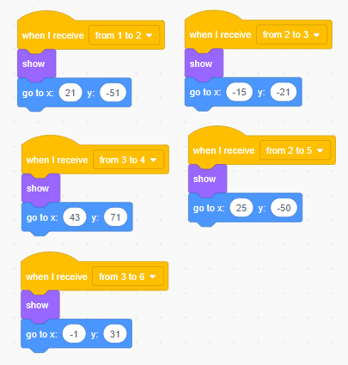

So yes, this is the code. When it receives the respective message from the broad cast, it will act accordingly.
The value of x and y are defining the position of star in different sprites (grounds).

Some bug fixes

We have used black color with the specifications defined above, this color us only used where the cat will move. There were no stopping boundaries. We had to control that manually. Such as sometimes cat goes beyond the boundaries where it should not be (the blue area) such as:
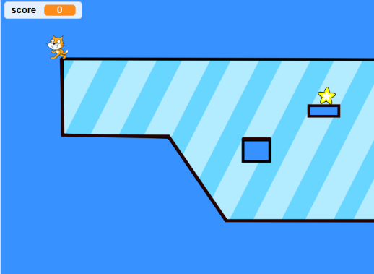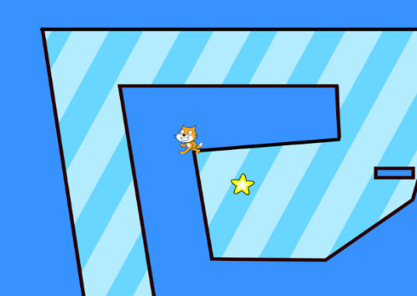

As we can see, the cat is moving beyond its limits, so to fix this problem, we made two variables, “old x” and “old y”. now we add the wall borders on each slide and assign it a specific black color which has the following specifications:
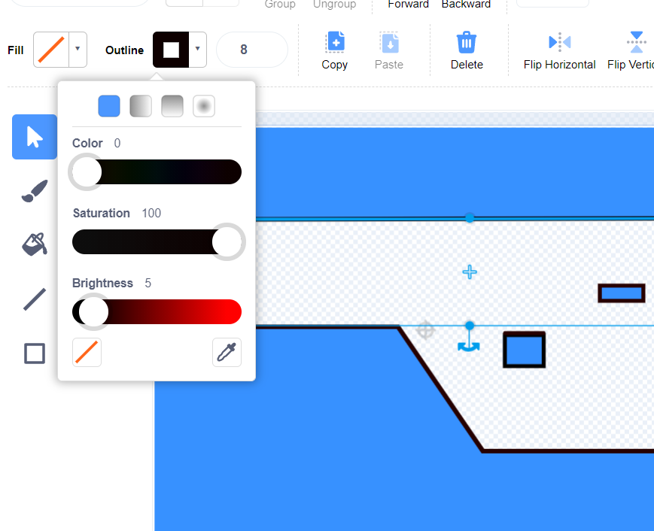

Now when the cat will touch this color, it will consider as a boundary. The question is, how so? So yes, the answer is right below.
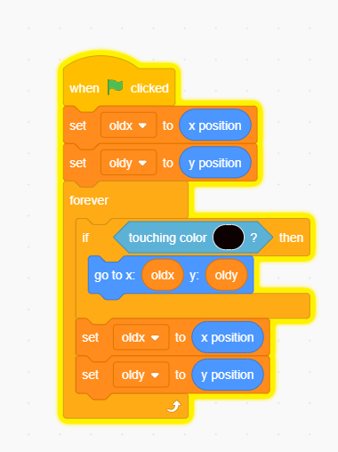
We assign the x and y position of the cat, when it is just before from touching that color, to those variables. Now whenever the cat touches that color, it will move to the previous position. And assign the new position to variables again.
Due to this, the cat will remain in the boundaries. Such as:
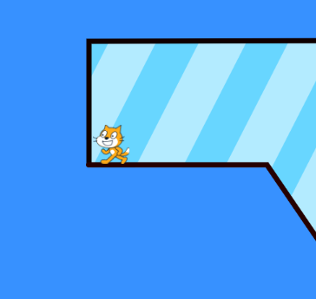
See this, I can’t move more even after pressing the “a” key (backward key). And you can see a minor gap between the cat and wall, this is how it works.

Jumping of Heroin Cat

As we cat see the heroin cat is jumping, it is very simple. For that, I customize a new costume of heroine cat in which she is rising her hands. Now at its defined location, I use a loop and change the value of Y by 5 and then switch to next costume and wait for a half second and then reverse the change in y and costume. Code is given below:
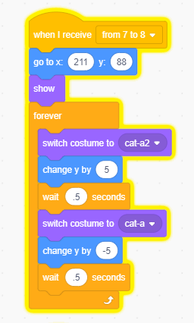

Winning

Now the objective of Game is to find the heroin cat, as soon as our cat meets the heroin cat, the game will terminate and winning screen will appear. How so? So, when the cat touches heroin cat, it will send a broadcast “winning” to all the sprites. And on winning broadcast, everyone will hide.
- Heroin cat
The following code is defined in the “heroin cat”.
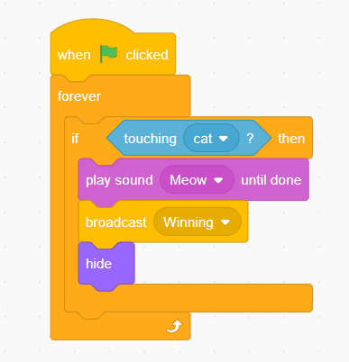
- All sprites
Now when any sprite will receive this winning message, it will hide itself.
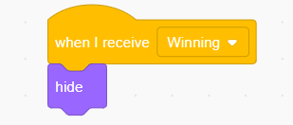
- Backdrop
And in the backdrop section, I added a winning screen. Now when the game starts, the backdrop will switch to “Background”. And when it receives “Winning message”, it will switch to “winning screen”.
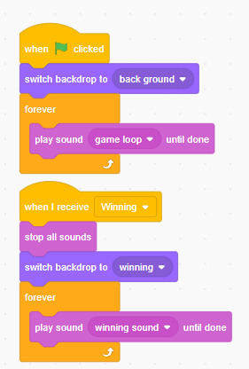

Loosing

For loosing, we also use specific colors. When cat touches those colors, the game will terminate with an ending sound which looks pretty cool. One of those color is our LAVA color, which is obviously orange and the other is specific RED color, which are small triangles.
- Colors
Following are the properties of both colors:
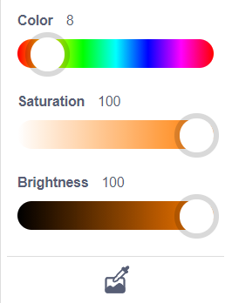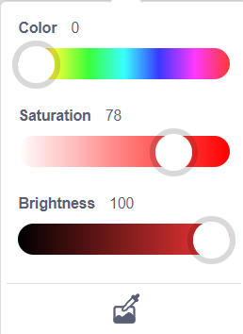
First one is our lava color and the second one is our triangles color.
- Cat code
The code for termination is written in the “cat” sprite. Which is given below:
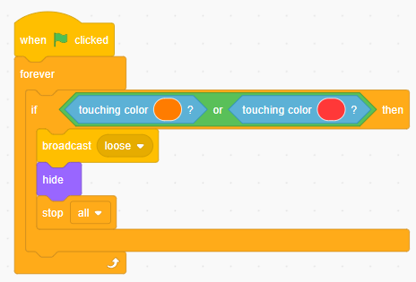
We can see, when the cat touches these specific colors, a broadcast message “loose” will generated the cat will hide itself.

- All Sprites
Now when any sprite will receive this “loose” message, it will hide itself.
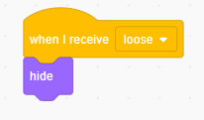

- Backdrop code
When the backdrop will receive the lose message, it will switch costume to “lose” costume and play a losing sound.
